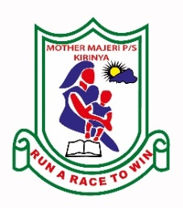**MOTHER MAJERI NURSERY SCHOOL**

**END OF TERM II EXAMINATION, 2024**

**CLASS : TOP CLASS**

**SUBJECT : General Knowledge**

My name is :_______________________________________Stream_______

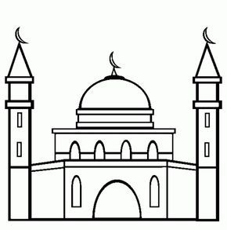**1. Match the correct word for the picture.**

church

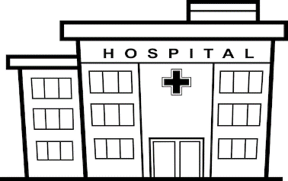police station

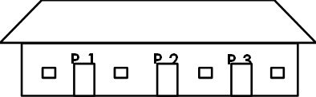market

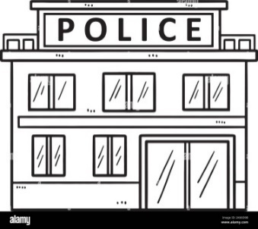

mosque

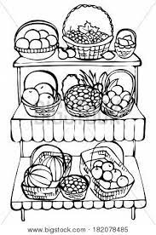

hospital

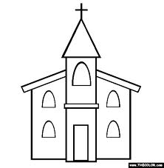

school

**2. Read and draw.**

|  |  |  |
| --- | --- | --- |
|  |  | Yam Doodle Vector & Photo (Free Trial) | Bigstock |
| fish | egg | yam |
|  |  |  |
| rice | cassava | beans |

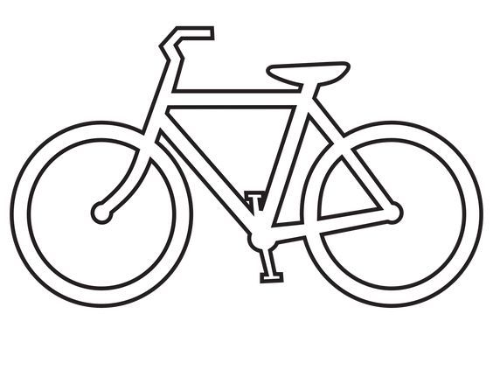**3. Fill in the missing letter.**

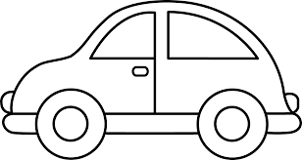

c__r bicycle

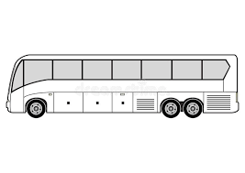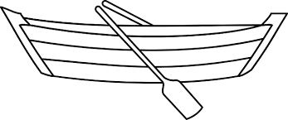

boa__ b__s

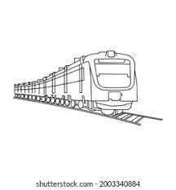

__rain

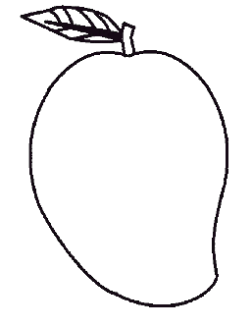**4. Underline the word for the picture.**

mango mat

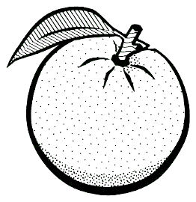

ox orange

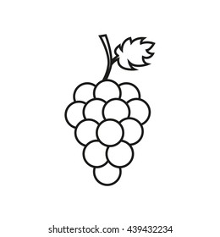

girl grapes

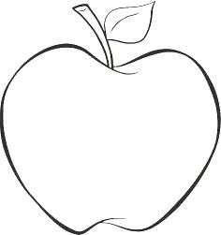

apple axe

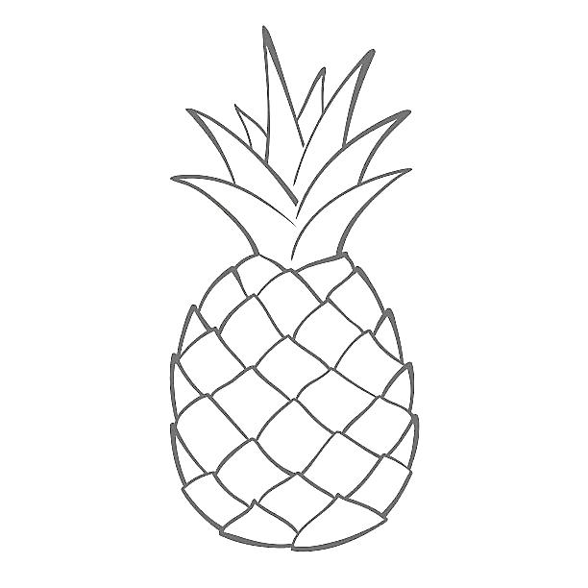

pin pineapple

[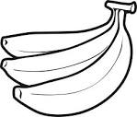](http://www.google.com/imgres?imgurl=http://www.newcoloring.net/wp-content/uploads/2013/05/banana-fruit-pictures-coloring-pages-for-kids-boys-girls-17.gif&imgrefurl=http://www.newcoloring.net/4657/banana-fruits-coloring-pages-free/&usg=__8cpaHwu5eOLB6ACLl_xYmd6Idg8=&h=826&w=972&sz=22&hl=en&start=12&zoom=1&tbnid=rUydnPEcsA9wwM:&tbnh=127&tbnw=149&ei=RdzsUbPXLYTYsga-jYDgAw&prev=/search?q=bananas&sa=X&hl=en&sout=1&biw=1341&bih=555&site=imghp&tbs=itp:lineart&tbm=isch&itbs=1&sa=X&ved=0CEQQrQMwCw)

bananas ball

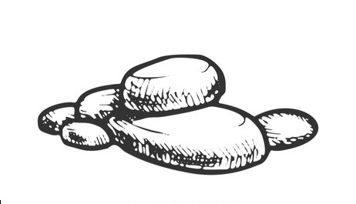**5. Name these pictures.**

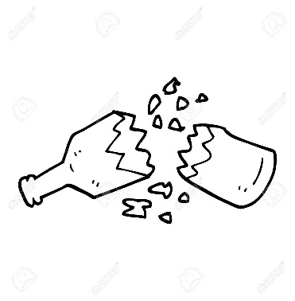

stone _____________

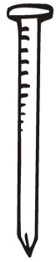[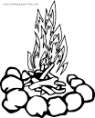](http://www.google.com/url?url=http://freecoloringpagesite.com/29-fire-coloring-pages.html&rct=j&frm=1&q=&esrc=s&sa=U&ved=0CDAQwW4wDGoVChMIuO_Sx8aRxwIVSW4-Ch0Syw1X&usg=AFQjCNGe_KpLdP8raKgNAx5-KSMyhn__YQ)

______________ _______________

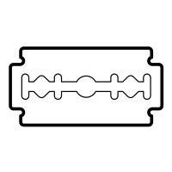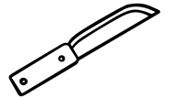

_____________ _______________

**6. Circle the correct word.**

book sponge

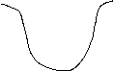

 water pencil



towel hen

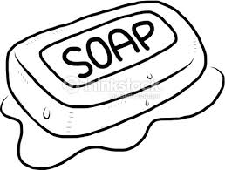

stool soap

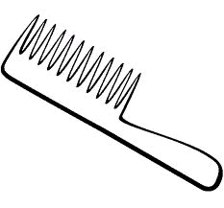

comb house

**7. Write the words correctly.**

wtera water

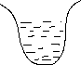

rstas ______________

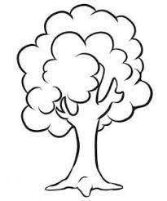

teres ______________

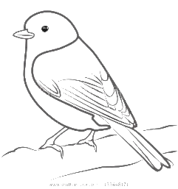



bdirs ______________

nmoo _____________

**END**